**Activity report**

**January to June 2019**

**Women with Disabilities Development Foundation (WDDF)**

We are concluded the following activities, during the period of January 2019 are as follows:

**1. Grassroots Women with Disabilities committee meeting:**

The aims of forming these grassroots Women with Disabilities committees in remote areas of different districts are as follows:

**I)** To introduce Women with Disabilities of the same union with each other as well as to establish a friendly relation among them through regular communication appearing in monthly meetings.

**II)** To encourage and motivate Women with Disabilities and their parents through reducing their negative attitude about disability.

**III)** To make Women with Disabilities self-conscious about their basic rights, contribution and self dignity in family and society through enhancing their self-confidence.

**IV)** To build leadership capacity of Women with Disabilities through enhancing awareness among them.

**V)** To provide information about disability related Government initiatives, documents along with facilities including NGOs as well as make them experienced on how to obtain these facilities through advocacy in different level.

**VI)** To adopt required initiative in order to include Women with Disabilities in local level including women related development process through their regular and active participation.

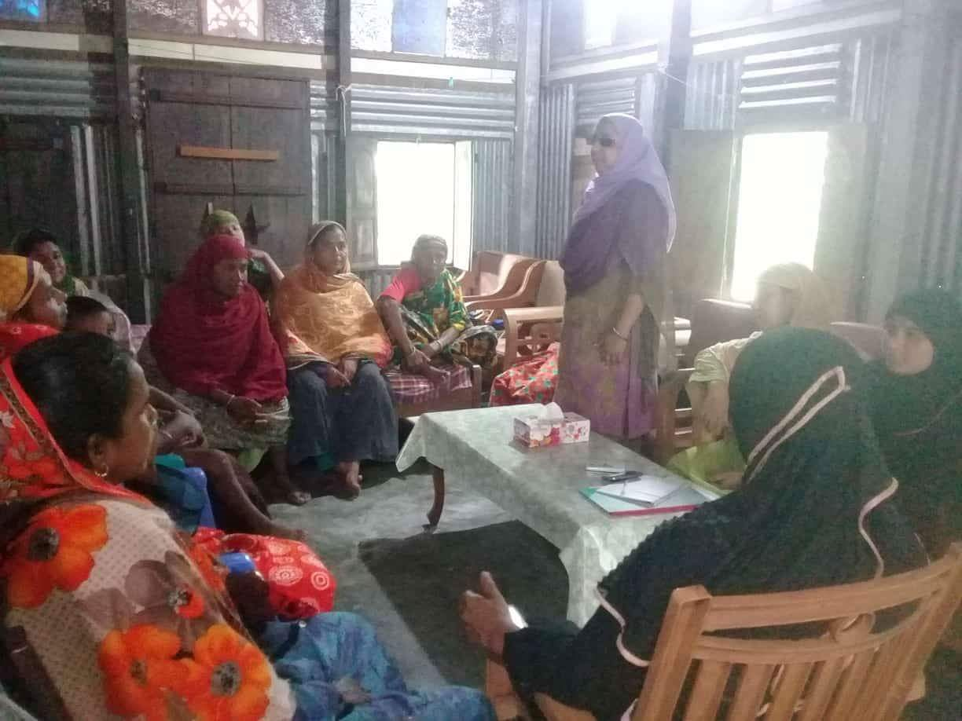**VII)** To create space in order to share multifaceted challenges in their daily lives , sufferings as Women with Disabilities including success E.G family conflict or discrimination, family/social violence, any type of torture/harassment and adopting the strategy of reducing these challenges and sufferings.

**VIII)** To encourage Women with Disabilities to be self-dependent mentally and financially through identifying their hidden capability as well as providing need based technical and financial support E.G training, assistive devise, financial support for small Income Generating Program.

**A)** The first discussion meeting with the Grassroots Women with Disabilities Committee of ‘Daudkandi Uttar’ and ‘Baropara’ Daudkandi, Cumilla was being organized by WDDF, at House of Masuma Akter, Vice Chairperson, WDDF of Kanora, Gouripur, Baropara Union on 8January 2019. This meeting is presided over Shirin Akhter, Chairperson, WDDF and representative of Daudkandi Grassroots Women with Disabilities committee with the cooperation of Masuma Akter, Vice Chairperson, WDDF and Arifa Khatun, Junior Assistant Coordinator of WDDF.

The discussed issues of this meeting were:

**I)** Introductory session.

**II)** Review the discussed issues of last meeting.

**III)** Discussion about rights of Persons with Disabilities according to “Persons with Disabilities Rights and Protection Act 2013”.

**IV)** Discussion about accessibility of Women with Disabilities in justice system.

**V)** Discussion about right of Persons/Women with Disabilities to obtain inherit property.

**VI)** Miscellaneous.

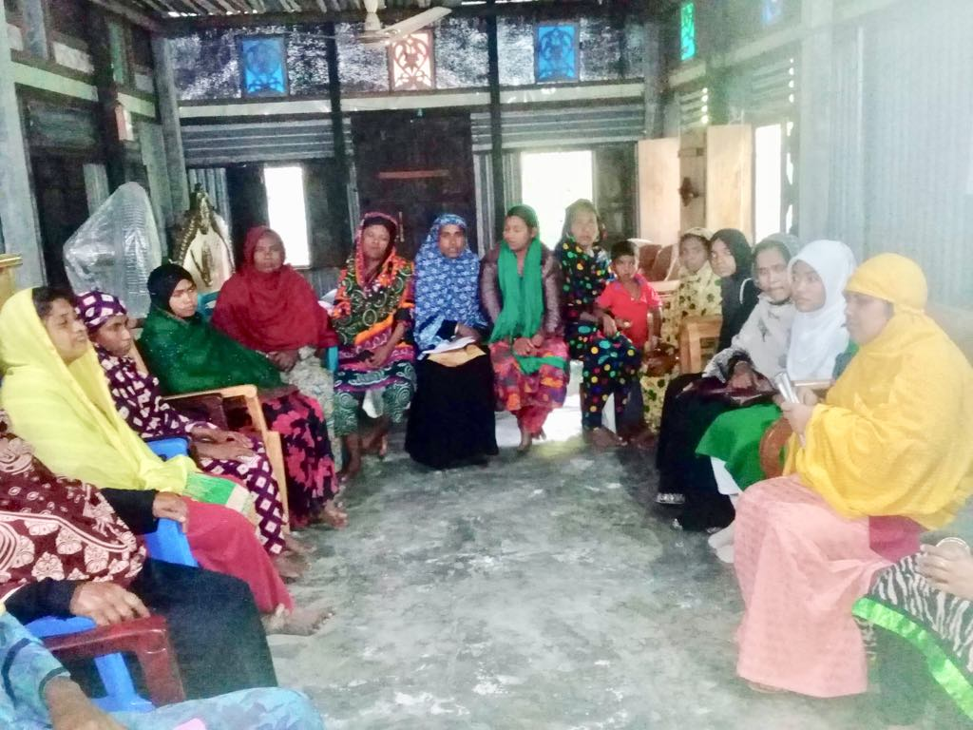**B)** The Second discussion meeting with the Grassroots Women with Disabilities Committee of ‘Gouripur’ and ‘Baropara’ Daudkandi, Cumilla was being organized by WDDF, at House of Masuma Akter, Vice Chairperson, WDDF of Kanora, Gouripur, Baropara Union on 9 January 2019.

This meeting is presided over Shirin Akhter, Chairperson, WDDF and representative of Daudkandi Grassroots Women with Disabilities committee with

the cooperation of Masuma Akter, Vice Chairperson and Arifa Khatun, Junior Assistant Coordinator of WDDF.

The discussed issues of this meeting were:

**I)** Introductory session.

**II)** Review the discussed issues of last meeting.

**III)** Discussion about rights of Persons with Disabilities according to “Persons with Disabilities Rights and Protection Act 2013”.

**IV)** Discussion about accessibility of Women with Disabilities in justice system.

**V)** Discussion about right of Persons/Women with Disabilities to obtain inherit property.

**VI)** Miscellaneous.

**2.** **Executive Council Meeting:**

An Executive Council meeting was held at WDDF office, on 12thJanuary 2019. There were almost ten participants including office staffs. Five agenda have been discussed including miscellaneous in this meeting.

**3. Advocacy meeting:**

An advocacy meeting on Disability Inclusive Disaster Risk Reduction Management was being organized by Centre for Disability and development (CDD) at the Auditorium of National Grassroot Disabled Organization (NGDO) on 17 January 2019.

Md. Abdul Hai, Junior Assistant Coordinator, WDDF participated in this advocacy meeting.

**4. M**onthly NGO Coordination Meeting:

A monthly NGO Coordination Meeting was being organized by District Commissioner at the Auditorium of DC office, on 20 January 2019.

Md. Abdul Hai, Junior Assistant Coordinator of WDDF participated in this coordination meeting.

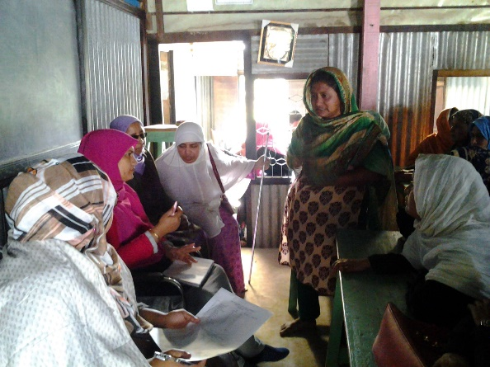**5. Grassroots Women with Disabilities committee meeting:**

The Third discussion meeting with the Grassroots Women with Disabilities Committee of ‘Daudkandi Uttar’, ‘Baropara’ and ‘Gouripur’Daudkandi, Cumilla was being organized by WDDF, at Mukul Niketan, Gouripur, Baropara Union on 26January 2019.This meeting is presided over Shirin Akhter, Chairperson, WDDF and representative of Daudkandi Grassroots Women with Disabilities committee with the cooperation of Masuma Akter, Vice Chairperson, Rounak Jahan Usha, Treasurer and Ashrafun Nahar, Executive Director of WDDF. Besides, Samira Haque, Accounts Coordinator, Md. Abdul Hai, Junior Assistant Coordinator and Arifa Khatun, Junior Assistant Coordinator, WDDF were present in this discussion meeting.

The discussed issues of this meeting were:

**I)** Introductory session.

**II)** Discussion about Income Generating Activities (IGA) for Women with Disabilities considering their types and grade of disability.

**III)** Miscellaneous.

At the end of discussion meeting Blankets have been distributed among poor Girls and Women with Disabilities and one goat has been distributed to a Woman with severe Intellectual Disability according to her demand in order to starting IGA.

**6. Discussion meeting:**

A discussion meeting of thematic group on Autism and Persons with Disabilities of National Human Rights Commission Bangladesh (NHRCB) titled ensuring access of Persons with Disabilities in Metro Rail and duties was being organized by National Human Rights Commission Bangladesh (NHRCB) in the Conference room of NHRCB at 10.00 AM, on 28 January 2019.

Md. Abdul Hai, Junior Assistant Coordinator, WDDF participated in this discussion meeting. He said that, Persons with Disabilities should be included in monitoring process of Metro rail management directly and they should also be included in employment process of Metro Rail.

**7. Seminar:**

A seminar titled **‘Analyzing Gender budgeting for women’s empowerment: Way forward’** was being organized by Manusher Jonno Foundation (MJF) in Conference room of MJF at 2.30 PM, 28 January 2019.

Shirin Akhter, Chairperson and Arifa Khatun, Junior Assistant Coordinator, WDDF participated in this seminar. Shirin Akhter focused on inclusion of Women with Disabilities in gender budgeting. She said that, particularly Ministry of Social Welfare and Ministry of Women and Children Affairs should include Women with Disabilities in gender budgeting of these ministries or allocate separate budget for Women with Disabilities considering gender diversity. Besides, each ministry including education and health should have allocate budget having mentioned the issues of Women with Disabilities specifically.

**8. Sharing meeting:**

A sharing meeting on report of 6 thematic issues of CEDAW Concluding observations was being organized by Steps towards Development (STD) at the Auditorium of STD on 29 January 2019.

Arifa Khatun, Junior Assistant Coordinator, WDDF participated in this sharing meeting.

**9.** **Discussion meeting with District Judge:**

A discussion meeting with the District Judge of Magura was being organized between the representatives of WDDF and the representatives including District Judge, Vice President, Secretary and other representatives of Magura District Judge Court at 3.00 PM, on 30th January 2019at the Conference room of Magura District Judge Court.

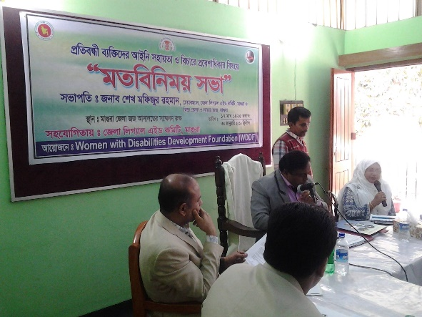Shirin Akhter, Chairperson, Ashrafun Nahar, Executive Director Samira Haque, Accounts Coordinator, Md. Abdul Hai, Junior Assistant Coordinator,WDDF and representatives of Disabled Peoples Organization to Development (DPOD) of Magura participated in the above mentioned discussion meeting.

Shirin Akhter, Chairperson, WDDF explicated the purpose and importance of organizing this discussion meeting in her welcome speech. Ashrafun Nahar, Executive Director, WDDF presented a key note paper including a few proposals and Shirin Akhter discussed about the complexity of Women with Disabilities in access to justice along with the inaccessibility in Court buildings and call upon the solidarity of the representatives of District Judge Court including bar association to this issue.

They’ve expressed their commitment that, they will always cooperate Persons/Women with Disabilities to file any litigation and to resolve any pending litigation or any type of legal cooperation.

They’ve also assured that, they’ll organize a number of sensitization programs about Persons with Disabilities simultaneously they will discuss and assigned a number of advocates to provide voluntary cooperation in order to resolve the litigations of Persons specially, Women with Disabilities.

SK. Mafizur Rahman, District Judge, Maura Judge Court, Sunanda Bagchi, Chief Judicial Magistrate, Magura Judge Court, Shimul Kumar Biswas, Joint District Judge, Magura Judge Court, S.M. Mahfuj Alom, Senior Judicial Magistrate, Magura Judge Court, Anusri Roy, Assistant Judge, Magura Judge Court, Md. Sajidur Rahman, General Secretary, Magura Bar Association, ADV Kawop Hossen, Public Prosecutor, Magura, ADV Md. Abdul Majid, Member, Magura Bar, ADVA. K. M. Shafiqul Islam, Member, Magura Bar, ADV Kamruzzaman, Lawyer, Gazi Eskander Islam, Lawyer, Shahina Akhter, Lawyer and Md. Shafiqul Islam, Lawyer were very cordial and cooperative to us; they expressed their commitment to adopt required initiative to reduce these challenges of Persons specially Women with Disabilities access to justice.

**10. Sharing meeting:**

A sharing meeting in order to share draft alternative report on Convention on Rights of Persons with Disabilities (CRPD) was being organized by National Grassroot Disabled Organization (NGDO) in collaboration with Bangladesh Legal Aid Services and Trust (BLAST) At Azimur Rahman Conference Hall, Daily Star Bhaban on 31st January 2019.

Arifa Khatun, Junior Assistant Coordinator, WDDF participated in this sharing meeting.

**1. Stakeholders Consultation:**

A Stakeholders consultation on draft report-State of minority Persons with Disabilities under Convention on Rights of Persons with Disabilities (CRPD) was being organized by Nagarik Uddyog at the Conference room of Nagarik Uddyog on 4 February 2019.

Ashrafun Nahar, Executive Director and Samira Haque, Accounts Coordinator, WDDF participated in this Stakeholders consultation. Ashrafun Nahar said that, articles of CRPD should be reviewed and article 30 **‘**Participation in cultural life, recreation,Leisure and sport’ should be added. She also noted that, the issues of minority groups should be included in Health policy clearly and wash facility should be highlighted for Girls with Disabilities. The properties of Persons with Intellectual Disabilities should be divided through ensuring guardianship and project should be adopted with the initiative of Government in order to work in city and grassroots level.

**2.** **Workshop:**

A workshop on **‘Reviewing Implementation of the Convention against Torture (CAT) in Bangladesh’** was being organized by Human Rights Forum of Bangladesh (HRFB) at the Conference room of NGO forum on 6 February 2019.

Shirin Akhter, Chairperson and Arifa Khatun, Junior Assistant Coordinator, WDDF participated in this workshop. Shirin Akhter focused on reducing long procedure of justice system and justice system should be free from the interference of the influential persons.

**3. Consultation:**

A consultation on **“Combating sexual harassment and Way Forward”** was being organized By National Human Rights Commission Bangladesh (NHRCB) in collaboration with Human Rights Program (HRP)-United Nations Development Program (UNDP) at Chameli House, CIRDAP Auditorium on 6 February 2019.

Ashrafun Nahar, Executive Director and Samira Haque, Accounts Coordinator, WDDF participated in this consultation. Ashrafun Nahar focused on formulating a comprehensive law and she noted with importance that, Non-Government Organizations, educational institutions, media and employers’ associations should be responsible to implement this law in order to protect women from sexual harassment. She also mentioned that, this comprehensive law will be activate to protect women from sexual harassment in community level and public transports as well as this comprehensive law should be disability inclusive.

**4.** **Consultation:**

A consultation on **“Promoting Accessible online library”** for the Persons with Visual Impairments and Print Disabilities was jointly being organized by Manusher Jonno Foundation (MJF), Young Power in Social Action (YPSA), Visual Impaired Peoples Society (VIPS) and Benetech at Conference room of MJF on 7 February 2019.

Shirin Akhter, Chairperson and Arifa Khatun, Junior Assistant Coordinator, WDDF participated in this Consultation. Shirin Akhter shared her delighted experience of becoming member of Bookshare. She said that, she came to know about Bookshare through Chirag and expressed her interest of becoming member; then with the cooperation of YPSA she achieved membership. After having achieved membership when she entered this largest online library called Bookshare, it seemed to her that, she is swimming in the sea of books; having seen such large number of collections of books she was surprised and couldn’t take decision which book she will read. Shirin Akhter also mentioned the complexity of reading and downloading online books, e.g. low speed of internet and lack of required reading softwares.

**5. Training:**

A three days training on **“Basic Bangla Sign Language”** was being organized bySociety of the Deaf & Sign Language Users (SDSL) at ZRT Conference Centre from 8 to 10 February 2019.

Md. Abdul Hai, Junior Assistant Coordinator, WDDF participant as trainee in this training.

**6. Reception to Vashkar Bhatta Chariya:**

A hearty reception was being enlightened by Visually Impaired Peoples Society VIPS to Mr. Vashkar Bhatta Charya, National Consultant, A2I, Bangladesh Government andProgram Manager, YoungPower in Social Action (YPSA)for obtaining United Nations Educational Scientific and Cultural Organization (UNESCO) Award, at Conference Lounge, National Press Club on 9 February 2019.

Ashrafun Nahar, Executive Director and Arifa Khatun, Junior Assistant Coordinator, WDDF participated in this reception program. Ashrafun Nahar enlightened heartiest congratulation on behalf of WDDF for this type of utmost achievement of Vashkar Bhatta Chariya simultaneously she expressed optimism that, with the leadership and representation of Persons with Disabilities and their organizations, more outstanding achievements will be brought to Bangladesh in future. 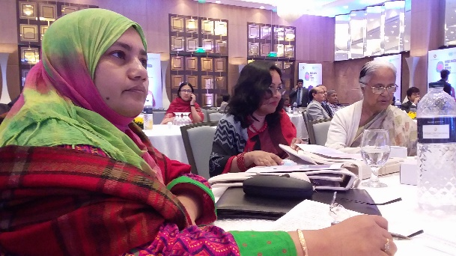

**7. Membership of ‘United Nations Human Rights Council’ Achieving Celebration Program:**

A celebration program titled ‘Bangladesh and Human Rights due to Bangladesh obtaining membership of United Nations’ Human Rights Council was being organized by Ministry of Foreign Affairs at Hotel Inter-Continental on 10 February 2019.

Ashrafun Nahar, Executive Director and Samira Haque, Accounts Coordinator, WDDF participated in this membership achieving celebration program.

**8. Discussion meeting:**

A discussion meeting about draft alternative report on Convention on Rights of Persons with Disabilities (CRPD) was being organized by National Grassroot Disabled Organization (NGDO) in collaboration with Bangladesh Legal Aid Services and Trust (BLAST) at the Auditorium of Bangladesh Institute of Law and International Affairs (BILIA) on 10 February 2019.

Ashrafun Nahar, Executive Director and Samira Haque, Accounts Coordinator, WDDF participated in this discussion meeting. Ashrafun Nahar provided important inputs for final correction of the alternative report.

**9. Project Orientation Meeting with Union Nirbahi Officer (UNO) of Daudkandi:**

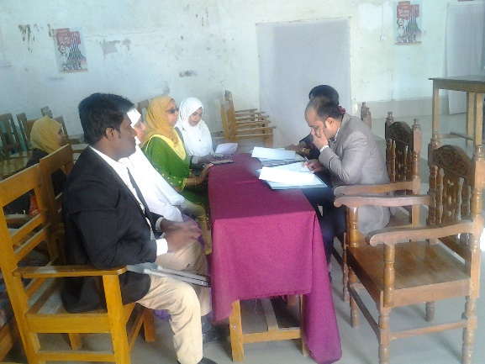A project orientation meeting with **Union Nirbahi Officer (UNO)** of Daudkandi in order to notify about the programs under the project titled “Non-discrimination and equity for Women and Girls with Disabilities” (December 2018-November 2019) is going to be implemented in Daudkandi was being organized by WDDF at Hall room of UNO office on 11 February 2019.

Shirin Akhter, Chairperson, Masuma Akter, Vice-Chairperson, Ashrafun Nahar, Executive Director and office staffs of WDDF were present in this discussion meeting. Ashrafun Nahar, Executive Director of WDDF discussed about project activities in local and national level briefly.

Shirin Akhter, Chairperson and Masuma Akter, Vice-Chairperson discussed about necessity of this project, direct experience of implementing project activities and the mentionable changes have been happened among Women with Disabilities of this working area due to growing awareness and self-confidence through implementing these projects by rotation. Samira Haque, Accounts coordinator, WDDF has notified about project budget and program wise expenditure.

UNO has expressed his satisfaction for advancement of our ongoing activities and he especially encouraged to observe piloting programs on Income Generating Activities (IGA) for Women with Disabilities of Daudkandi. So, he suggested to increase budget for IGA of Women with Disabilities and he asked to submit activity wise budget of the programs will be organized in Daudkandi after having completed this project.

**10. Grassroots Women with Disabilities committee meeting:**

**A)** First discussion meeting with the Grassroots Women with Disabilities Committee of ‘Daudkandi Uttar’ and ‘Baropara’ Daudkandi, Cumilla was being organized by WDDF, at House of Masuma Akter, Vice Chairperson, WDDF of Kanora, Gouripur, Baropara Union on 12 February 2019.This meeting is presided over Shirin Akhter, Chairperson, WDDF and representative of Daudkandi Grassroots Women with Disabilities committee with the cooperation of Masuma Akter, Vice Chairperson, WDDF and Arifa Khatun, Junior Assistant Coordinator of WDDF.

The discussed issues of this meeting were:

**I)** Introductory session.

**II)** Review the discussed issues of last meeting.

**III)** Discussion about disability and development.

**IV)** Discussion about advantages of including in Grassroots Women with Disabilities Committee.

**V)** Discussion about advantage and process of including in disability survey.

**VI)** Miscellaneous.

**B)** Second discussion meeting with the Grassroots Women with Disabilities Committee of ‘Gouripur’ and ‘Baropara’ Daudkandi, Cumilla was being organized by WDDF, at House of Masuma Akter, Vice Chairperson, WDDF of Kanora, Gouripur, Baropara Union on 13February 2019.

This meeting is presided over Shirin Akhter, Chairperson, WDDF and representative of Daudkandi Grassroots Women with Disabilities committee with the cooperation of Masuma Akter, Vice Chairperson and Arifa Khatun, Junior Assistant Coordinator of WDDF.

The discussed issues of this meeting were:

**I)** Introductory session.

**II)** Review the discussed issues of last meeting.

**III)** Discussion about disability and development.

**IV)** Discussion about advantages of including in Grassroots Women with Disabilities Committee.

**V)** Discussion about advantage and process of including in disability survey.

**VI)** Miscellaneous.

**11. Consultation:**

A consultation on Web accessibility of Persons with Disabilities was jointly being organized by Manusher Jonno Foundation (MJF), Young Power in Social Action (YPSA) and Visual Impaired Peoples Society (VIPS) at Conference room of MJF on 16 February 2019.

Shirin Akhter, Chairperson and Arifa Khatun, Junior Assistant Coordinator, WDDF participated in this Consultation.

**12. Workshop:**

A feminist workshop was jointly being organized by UN Woman Bangladesh and UNDP at Conference room of UN Woman office on 18 February 2019.

Md. Abdul Hai, Junior Assistant Coordinator, WDDF participated in this workshop. He focused on discrimination faced by Persons/Women with Disabilities.

**13. International Program (19-25 February 2019):**

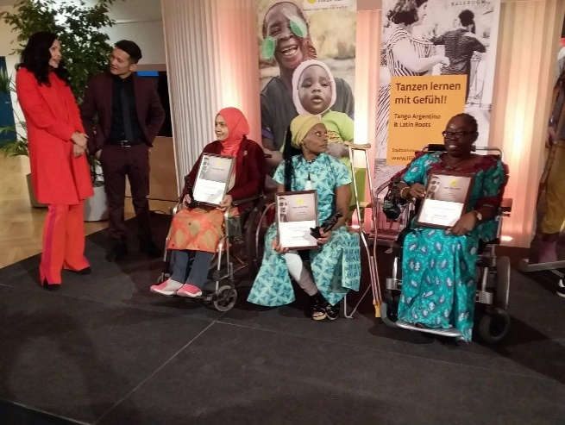Ashrafun Nahar, Executive Director, WDDF has achieved the first Global award for Women with Disabilities “Her Abilities” in Rights Category, announced by Light for the World on 3rd December 2018. In order to receive the award “Her Abilities” Ashrafun Nahar was being invited and participated at Zero Conference and award distribution ceremony, organized by Light for the World in Vienna, Austria from 19-25 February 2019. After having participated in this conference, she participated in a number of discussion meetings with Light for the World and awardees in order to share the situation of Women with Disabilities of Bangladesh, her struggle for achieving their rights, experience as well as thoughts of evolving rights of Women with Disabilities. Besides, she chaired a session titled **“Rights of Women with Disabilities and movement”** and received award through participating in award distribution ceremony which is certainly a great achievement for Women with Disabilities of Bangladesh.

**14. Workshop:**

A preparatory workshop for CSW 63 was being organized by Ministry of Women and Children Affairs (MOWCA) in collaboration with UN Woman Bangladesh at Pan Pacific Sonargaon Hotel on 19 February 2019.Shirin Akhter, Chairperson and Samira Haque, Accounts coordinator, WDDF participated in this workshop. Shirin Akhter said that, all types of infrastructures should be sustainable and inclusive for all types of Persons/Women with Disabilities. All types of initiatives for women development should be disability inclusive and should be implemented considering gender diversity including Gender with Disabilities.Development plans and programs should be adopted and implemented considering special requirements of gender diversity including Gender with Disabilities.

**15. Conference:**

A conference titled “Third ICSD International Conference on Sustainable Development towards creating a green future.”Thematic area: Disability and SDGs: A parallel session on the thematic area titled ‘Disability and SDGs’ of the third international conference on Sustainable development was jointly being organized by United International University (UIU), CBM International Bangladesh Coordination office and Action on Disability and Development (ADD) International Bangladesh at the auditorium of UIU on 20 February 2019.

Shirin Akhter, Chairperson and Samira Haque, Accounts coordinator, WDDF participated in this conference. Shirin Akhter emphasized on Disability Inclusive Disaster Risk Reduction Management considering not only the situation of Persons with mild Disabilities but also considering requirements of diverse group of gender and severity of disability. She also emphasized on considering infrastructural and informational accessibility and inclusiveness of all types of Persons with Disabilities in all development agenda otherwise the determination of **“Leave No one behind”** of SDGs won’t be fulfilled and Persons especially Women with Disabilities will be excluded.

**16. Press Conference:**

A press conference titled to protest for 67 peoples’ death by destructive conflagration at Chakbazar and negligence to actualize the order of High Court was being organized by Human Rights Forum Bangladesh (HRFB) at Sagar Runi Hall, Dhaka Reporters Unity on 24 February 2019.

Shirin Akhter, Chairperson and Arifa Khatun, Junior Assistant Coordinator, WDDF participated in this press conference. After having expressed compassion to the peoples and their family who died by the destructive fire of Chakbazar Shirin Akhter said that, realistic and time required measures should be adopted to prevent this type of petrifying accident. She urged that, a list should be prepared of Persons with Disabilities affected through this accident or the Persons who become disabled by Chakbazar accident and long term treatment and rehabilitation should be provided besides regular monitoring. She also urged to the representatives of mass media to publish report about the situation of affected Persons with Disabilities through this accident including their list.

**17. Executive Council meeting:**

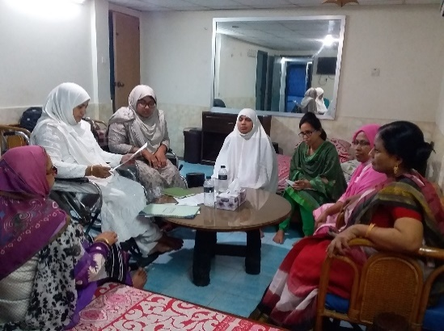An Executive Council meeting was held at WDDF office, on 27 February 2019. There were almost thirteen participants including office staffs. Eight agenda have been discussed including miscellaneous in this Executive Council meeting. The agenda were as follows:

**1.** Discussion of last meeting minutes and approved,

**2.** Discussion about preparation of Annual General Meeting (AGM) and election,

**3.** Discussion about annual Activity report and financial statement 2018 and approved,

**4.** Discussion about proposed Action plan and Budget 2019and approved,

**5.** Discussion about staff appointment and approved,

**6.** Submission of Audit report 2018 as well as discussion of Auditor appointment and approved

**7.** Discussion about Executive Council Member selection and approved,

**8.** Miscellaneous.

**18. Annual General meeting (AGM) and Picnic:**

Annual General Meeting (AGM) and Picnic were being organized with the initiative of Women with Disabilities Development Foundation (WDDF) at Pubail Socio Cultural Resort Centre (PSCRC) from 27 to 28 February 2019. Twenty one General members participated in these above mentioned events but the total number of participants of these events including volunteers, guides and support staffs were almost twenty eight. AGM has started at 10 am, on 28 February 2019. Shirin Akhter, Chairperson, WDDF presided over AGM. She started this AGM expressing her gratitude, gratification and appreciation at first to almighty Allah and then to WDDF for having the opportunity to organize this AGM and Picnic in such fascinating and enjoyable natural environment. She also expressed gratitude and thanks to all General Members, staffs and volunteers for their active and spontaneous presence and participation. After that, she requested Ashrafun Nahar, Executive Director, WDDF to facilitate the AGM.Ashrafun Nahar has also started to facilitate the discussion through expressing her gratitude and satisfaction to Almighty Allah. She presented the agenda of the Annual General Meeting (AGM) expressing heartiest gratitude and thanks on behalf of WDDF to all the members for their presence. There were seven agenda including miscellaneous. The presented agenda of this meeting were as follows:

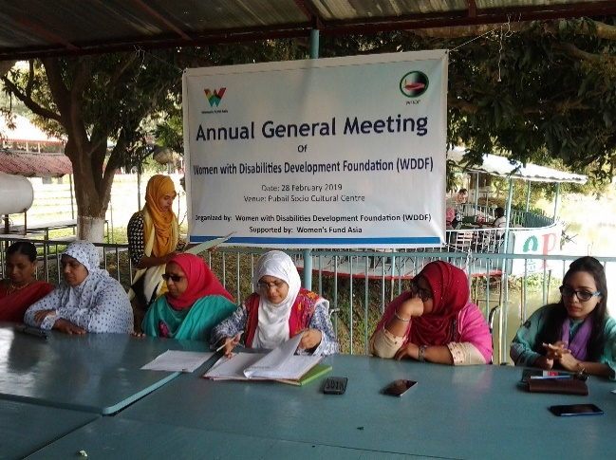1. Discussion about Annual Activity Report 2018 and approved.

3. Discussion about annual financial statement/Audit report of 2018and approved,

4. Discussion about General and Executive Council Member Co-opt, member selection and approved,

5. Submission of proposed action plan and budget 2019as well as discussion of Auditor appointment and approved,

6. Executive Council election.

7. Miscellaneous.

A) Ashrafun Nahar, Member Secretary of WDDF submitted the last meeting minutes and in accordance with the opinions of all the General Council (GC) members the last meeting minutes is being approved.

B) The Vice-Chairperson of WDDF Submitted the Annual Activity Report of 2018 and in accordance with the opinions of all the GC members the submitted Annual Activity Report is being approved.

C) Treasurer (Rounak Jahan Usha) of WDDF with the cooperation of Accounts Coordinator submitted the annual financial statement/Audit report of 2018 and in accordance with the opinions of all the GC members the submitted annual financial statement/Audit report of 2018 is being approved.

D) Treasurer (Rounak Jahan Usha) submitted the proposed Action plan and Budget 2019 to all the GC members and in accordance with the opinion of all the GC members, the submitted proposed action plan and budget 2019 is being approved.

E) In accordance with the opinion of all the GC members it is decided that the responsibility of appointing auditor has been handed over the Chairperson and treasurer of WDDF.

F) Election of Executive Council Members is being organized in selection system and seven Executive Council Members are being selected through election of General Council Members for five years.

In conclusion, Chairperson expressed the optimism that, Women with Disabilities will lead their lives with self-dignity, self-independence along with contributive citizens for the state through the activities of WDDF. Simultaneously, with the expansion and leadership of WDDF a contributive role will be played by Women with Disabilities for their advancement in international level.

Finally, she expressed heartiest gratitude on behalf of herself to the General Council Members for their continuous suggestion, support and cooperation for the advancement of WDDF and declared the closing of the Annual General Meeting for that day.After that, a gift distribution session has been organized for all participants.

**Picnic:**

After long expectation of WDDF team, the amusing and delighted day of picnic has appeared for them.Actually, WDDF team has started the journey for picnic in the late afternoon of 27 February 2019. We’ve arrived at 6 PM on that day at Pubail Socio Cultural Resort Centre (PSCRC), Gazipur and our members are very fascinated to visit this resort abounded with natural beauty. We’ve seated near the swimming pool, shared our childhood memories taking snacks and coffee, many of our members were singing songs and presented comics.

Exclusively, we’ve passed an extraordinarily delightful evening with all of our members, staffs and volunteers. After having a peaceful and sound sleep, at early morning of 28 February we’ve gone for swimming and we all more or less have participated in swimming in a safe, secured and women friendly environment. In Bangladesh, this large number of Women with Disabilities group has hardly obtained opportunity and gone for swimming. So, this event is very enjoyable and memorable for WDDF team.Besides, there were opportunities of boating and different types of sports items including Cradle. So, we haven’t miss the opportunity of rocking which was one of the amusing moments for us and at the time of rocking, we went back to our impressive childhood over and over again.

**1. Discussion meeting:**

A discussion meeting on role of Non-Government Organizations (NGOs) to prevent torture against women and children was being organized by Ministry of Women and Children Affairs (MOWCA) in collaboration with NGO Affairs Bureau at the Conference room of NGO Affairs Bureau on 5 March 2019.

Ashrafun Nahar, Executive Director and Samira Haque, Accounts coordinator, WDDF participated in this discussion meeting.

**2. Day observance “International Women day”:**

A discussion meeting and a cultural program on the occasion of International Women day were being organized by Ministry of Women and Children Affairs (MOWCA) at Bangabandhu International Conference Centre (BICC) Bhaban on 9 March 2019.

Honorable Prime Minister Sheikh Hasina of Bangladesh was present as Chief Guest, Meher Afroz Chumki, Chairman, Parliamentary Standing Committee, MOWCA, the Secretary along with other relevant officers of MOWCA, a number of Ministers and MPs were present in this program. Besides, Country Representative from UN Women as well as the representatives of DPOs, GOs, NGOs and CSOs were present. General Council and Executive Council members, Shirin Akhter, Chairperson, Arifa Khatun, Junior Assistant Coordinator and Md. Abdul Hai, Junior Assistant Coordinator of WDDF participated in the abovementioned programs.

**3. International program Commission on the Status of Women (CSW) 63 Session:**

Commission on the Status of Women (CSW) 63 session was being organized by United Nations in New York, USA from 14 to 24 March 2019. With the representatives of Government and CSOs, on behalf of Women with Disabilities of Bangladesh, Ashrafun Nahar, Executive Director, WDDF participated in this session from 11 to 19 March 2019. She has participated in nine sessions and a number of discussion meetings. In three sessions she raised following questions:

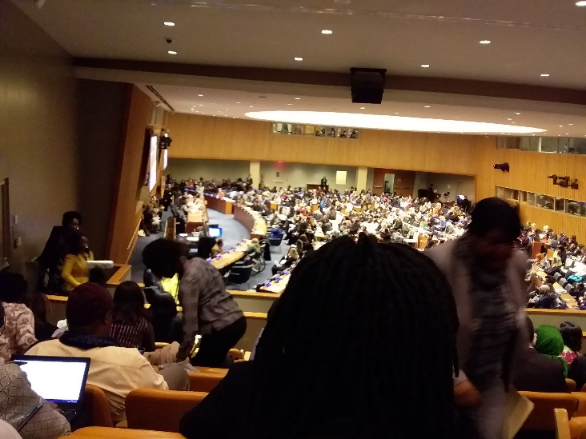 1. What type of initiative or mechanism has been adopted for social inclusion of Girls and Women with Disabilities?

2. According to her knowledge and experience, Girls and Women with Disabilities have no equal access in Government services globally but what is the situation in Australia and Thailand? And what types of initiative have been taken by both of the Government?

3. What type of initiative or mechanism has been adopted in order to include Gender with Disabilities in gender budgeting?

In one session titled **“Women Empowerment and peace building”** she has participated as a panel speaker on Women refugees with Disabilities. In her presentation she highlighted on following issues

I) Challenges of Women Refugees with Disabilities,

II) Background

III) How to start support to Rohingya refugees,

IV) Situation of Rohingya Women refugees with Disabilities at a glance,

V) Agreement of WDDF for a need based assessment of Rohingya Women refugees with Disabilities,

VI) Causes of having given priority to work on the issue of Rohingya Women with Disabilities,

VII) Essential issues for empowerment of Rohingya Women refugees with Disabilities and peace building.

In discussion meetings She focused on the adverse condition of women and girls with disabilities in rural communities and ICT, digitalization. She noted that, the situation of Bangladesh is most disadvantage categories as Government has no specific initiatives for women and girls with disabilities. The situation of Sweden is better. Government has different and specific initiatives for women and girls with disabilities empowerment through providing suitable assistive devices, health care and insurance, incentive care for daily living and education, open the employment opportunity or unemployment allowance, freedom from any type of barrier, accessible road and transportation. So, it is said that, Citizens with Disabilities of Sweden are living in inclusive society for all. USA also has American Disability Act which supports all types of cooperation for enjoying as equal as other citizens. As women with disabilities of all countries have some limitations but most of the countries have taken measures to 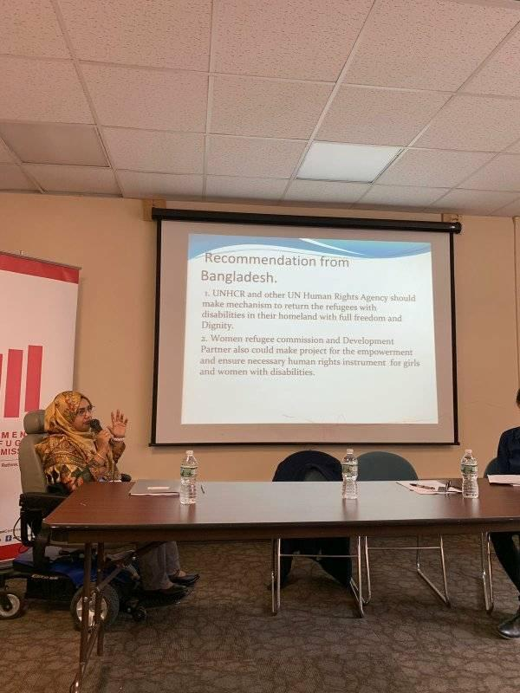meet up the limitations except Bangladesh.

In her presentation she has also briefly presented the very grassroots situation and focus on the gaps which has not considered on the basis of priority for the empowerment of women and girls with disabilities from family to state level though we have Persons with Disabilities Rights and Protection Act 2013, Government has signed and ratified Convention on Rights of Persons with Disabilities (CRPD).

From More other 6 sessions where she was present as participant were wonderful discussion but it is still disappointing to her that most of the speakers always forget to speak about the situation of Women with Disabilities And in most cases only women and girls with disabilities raise their own issues. Still disability is less priority issue and not focusing the route cases for empowerment of Women with Disabilities issues in the global Women rights Movement. In this year she has followed girls and women with disabilities participation is also lower than other years. She had participated for too short time and at the beginning sessions. So, it could be enhanced up to other sessions.

It is very important to enhance the participation of women with disabilities activists otherwise the issue of Women with Disabilities will not be addressed properly and it will be alarming to achieve SDGs for different countries including Bangladesh.

**4. Consultation:**

A consultation on List of Issues in relation to the CRPD initial report of Bangladesh was being organized by Human Rights Group of United Nations Country Team (UNCT) at the Auditorium of United Nations Residence Coordinator’s office, IDB Bhaban, Agargaon on 12 March 2019.

Shirin Akhter, Chairperson and Samira Haque, Accounts coordinator, WDDF participated in this consultation. Shirin Akhter Emphasized on following articles and issues, e.g.

I) Accessibility

II) Women with Disabilities

III) Access to justice

IV) Health

V) Education

VI) Access to Government services and facilities

VII) Disability survey

VIII Disability inclusive legislation and policy

IX) Quota implementation in employment

X) Violence against Women with Disabilities and

XI) Attitudinal, social and environmental barriers of Persons with Disabilities.

Besides, on behalf of WDDF written list of Issues (LOIs) on CRPD initial report of Bangladesh has been submitted to UNCT.

**5. Reminiscence Meeting:**

A reminiscence Meeting on the occasion of death anniversary of Rafiq Zaman Rimu with his family was being organized by Protibondhi Nagarik Sangathaner Parisad (PNSP) at the Auditorium of PNSP office at 4.00 PM, on 12 March 2019.

Arifa Khatun, Junior Assistant Coordinator WDDF participated in this reminiscence meeting.

**6. Discussion meeting:**

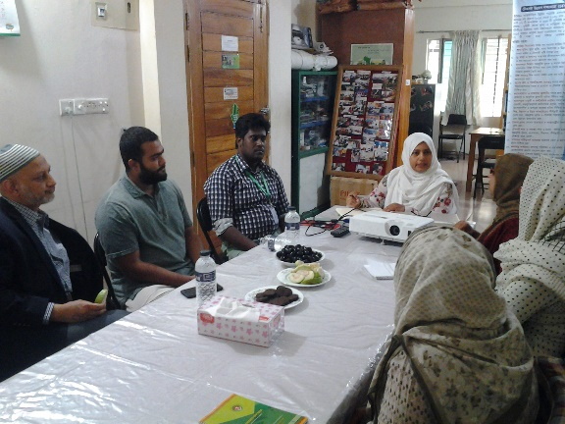A discussion meeting with Executive Director of North American Humanitarian Aid and Relief (NAHAR) was being organized by Women with Disabilities Development Foundation (WDDF) in its office on 22nd March 2019.

Shirin Akhter, Chairperson, Ashrafun Nahar, Executive Director, Rounak Jahan Usha, Treasurer and office staffs of WDDF were present in this discussion meeting. Key areas of WDDF activities, main activities and situation of Women with Disabilities are being discussed in this discussion meeting elaborately.

**7. Workshop**:

A workshop schedule on Charter of Demand was being organized by Naripokkho at the Auditorium of Naripokkho office on 23rd March 2019.

Rounak Jahan Usha, Treasurer and Arifa Khatun, Junior Assistant Coordinator, WDDF participated in this workshop. Rounak Jahan Usha discussed about situation, rights and demands of Women with Disabilities and in order to include the demands of Women with Disabilities in the Charter of Demand, written recommendation has been submitted on behalf of WDDF.

**8. Validation and program design workshop:**

A Validation and program design workshop titled “effective approaches to preventing Violence against Women” was being organized by UN Women-Bangladesh at Hotel Royal Park, Banani on 24 March 2019. Shirin Akhter, Chairperson and Arifa Khatun, Junior Assistant Coordinator, WDDF participated in this workshop. Shirin Akhter discussed about specific causes of violence against Women with Disabilities in highest rate than nondisabled women elaborately, e.g.

I) Inaccessible justice system for Women with Disabilities

II) Long procedure of justice system

III) Family and social barriers, negligence and technical non-cooperation to file complain

IV) Disability exclusive legislation and policy and so on.

**1. Day Observance”** World Autism Awareness Day”**:**

A discussion meeting and a cultural program on the occasion of twelfth World Autism Awareness Day were being organized by Ministry of Social Welfare at Bangabandhu International Conference Centre (BICC) Bhaban on 2nd April 2019.

Honorable Prime Minister Shiekh Hasina of Bangladesh was present as Chief Guest, Nuruzzaman Ahmed, Minister and Sharif Ahmed, State Minister, Ministry of Social Welfare, the Secretary along with other relevant officers of Ministry of Social Welfare, a number of Ministers and MPs were present in this program. Besides, the representatives of DPOs, especially representatives of the organizations working with Persons with Neuro Developmental Disabilities, GOs, NGOs and CSOs were present. General Council and Executive Council members of WDDF were present in the abovementioned programs.

**2. Consultation:**

A Consultation with the representatives of Leonard Cheshire (LC) was being organized By World Bannk at the Auditorium of World Bank office at 3.30 PM, on 2nd April 2019.

Ashrafun Nahar, Executive Director and Samira Haque, Accounts coordinator, WDDF participated in this consultation. Emphasizing on inclusion of Persons with Disabilities of grassroots level, Ashrafun Nahar said that, number of Persons with Disabilities is higher in grassroots level so, need based programs should be adopted considering their types and capabilities. Particularly Women with Disabilities should be connected with information and technology through enhancing their working efficiency.

**3. Dialogue:**

A dialogue titled **“Access to justice of Women with Disabilities: Role of different institutions and mass media”** was being organized with the initiative ofWomen With Disabilities Development Foundation (WDDF) **at Azimur Rahman Conference Hall, the Daily star Bhaban** at 10.00 AM, on Saturday, 6th April 2019.

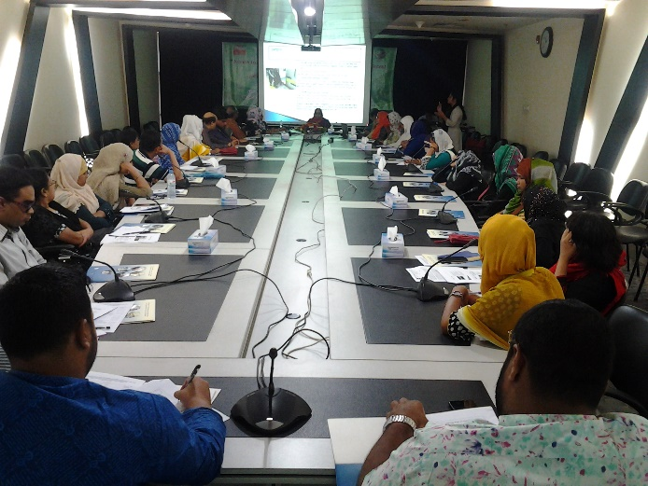Welcome Speech was being delivered by Shirin Akhter, Chairperson, Women with Disabilities Development Foundation (WDDF) and she enlighten that, at the time of working for Women with Disabilities, they’ve to face multifaceted barriers; especially the challenges have to be faced by Women with Disabilities in justice system for obtaining their justice which won’t be possible to resolve through distinctive work. Though there is no inadequacy of legislation, any explicit directive haven’t been mentioned about judgment procedure of Women with Disabilities in legislations.

The involvement of legal support and shelter providing organizations simultaneously relevant service providing institutions with these issues are immensely important for obtaining justice of Women with Disabilities. She also mentioned that, for imploring judgment of tortured female child or Woman with Disability, the family members have to be tortured and punished even imprisoned as criminal. So, obtaining judgment for Women with Disabilities will be easy whether mass media and other service providing institutions provide continuous service and cooperation with sincerity.The dialogue was being moderated and keynote paper was being presented by Ashrafun Nahar, Executive Director, and Women with Disabilities Development Foundation (WDDF). In this paper she urged that, at the side of inconsistency and incongruity of society, the representatives of mass media should publish the monitoring reports of improper and proper implementation of legislations for getting judgment of Women with Disabilities. She also said that, service providing institutions to victim women of torture and violence, legal support providing NGOs, law inforcement agencies, GOs and NGOs working for establishing women rights, Disabled Peoples Organizations (DPOs) and NGOs working for Persons/Women with Disabilities, One Stop Crisis Centre (OCC) and national and international donor organizations should ensure accessible infrastructure and information services for Persons with Disabilities and appoint responsible and trained officers about preserving and protecting rights of Persons with Disabilities. Mentioning about the statistics of Women with Disabilities she said that, according to the household survey of Bangladesh Bureau of Statistics (BBS), 9.07% of total population are Persons with Disabilities. According to the World Health Organization (WHO) June 2011, almost 15% of total population of Bangladesh are Persons with Disabilities approximating to all developing countries. So, according to that statistics, number of Persons with Disabilities is approximately 24 million, among them, number of Women with Disabilities is 12 million. In this paper, it is stated that, 99% Women with Disabilities are living under poverty line and less than 1% female Children with Disabilities are getting opportunity of going to school.

96% Women with Disabilities are becoming victim of mental, physical and sexual violence. According to the reports of different newspapers up to 2016, it is seen that, number of violence happening to Women and Female children with Disabilities is very high but the number of publishing reports regarding violence is very limited. From research and real experience it is seen that, Whether Women with Disabilities have become Victim of violence once; in most cases, she has to become victim of violence again and again. 78% Women and female children with Disabilities are become victim of different types of physical and sexual violence only due to their own limited power of prevention (BLAST) and among them 18% is become victim of violence again and again.

Participated media representatives are expressed the same concern with this paper and acknowledged their accountability to Persons including Women with Disabilities.

Respected Guests of dialogue said that, in spite of having been formulated national and international legislations and policies in order to establish right based and anti-discriminatory society for Persons with Disabilities and to include them in entire women rights, development of the state, these legislations and policies haven’t been implemented and actualized.

All legislations and policies including “Persons with Disabilities Rights and Protection Act 2013”, “Neuro Developmental Disability Trust Act 2013”, “Convention on Rights of Persons with Disabilities (CRPD)” and “Sustainable Development Goals (SDGs)” should be included in 7th5 year plan and National Social Security Strategy (NSSS).

In open discussion of the dialogue speakers are said that, the issue of Persons with Disabilities hasn’t been included in 7th5 year plan properly and in this consequence, they’re excluded from development plan. But the main theme of SDGs is “no one Leave behind”.

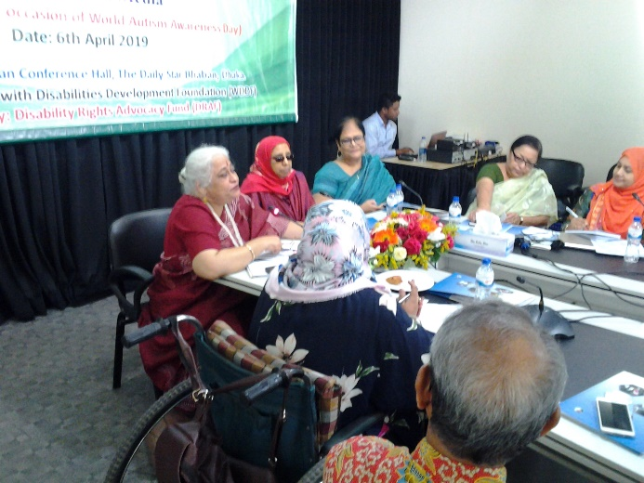All ministries including Social Welfare Ministry should take responsibility to include Women with Disabilities in entire development of the state. Besides, guests are also discussed the barriers of social inclusion of Women with Disabilities and ways of eliminating barriers elaborately. Simultaneously, they’ve expressed their commitment to adopt required initiative to include Women with Disabilities in entire development of the state.

Ms. Aroma Dutta, Member of Parliament, National Parliament, The Peoples’ Republic of Bangladesh was present as Chief Guest in the dialogue.Besides, Ms. Sheepa Hafiza, Executive Director, Ain o Salish Kendra, Convener, Human Rights Forum Bangladesh (HRFB) and Zakia K Hassan**,** President, DIPTO Foundation and Development Analyst and Researcherwere present as special Guests; Disability rights activists and experienced discussants were present as panelists.

Chief Guest and special guests are suggested to prepare a set of recommendations on the basis of discussion of this dialogue and Chief Guest expressed her commitment that she will organize a discussion meeting between the representatives of Disabled Peoples Organizations (DPOs) and the Parliamentary Standing Committee of Social Welfare Ministry before National Budget session.

Vote of thanks was being delivered by Rounak Jahan Usha, Treasurer, WDDF.

**4. Consultation:**

A consultation on List of Issues in relation to the Convention on Rights of Persons with Disabilities (CRPD) initial report of Bangladesh was being organized by Human Rights Group of United Nations Country Team (UNCT) at the Auditorium of United Nations Residence Coordinator’s office, IDB Bhaban, Agargaon on 8 April 2019.

Shirin Akhter, Chairperson and Samira Haque, Accounts coordinator, WDDF participated in this consultation. In this Consultation the representatives of CRPD alternative report preparing platform, Civil Society Organizations (CSOs) and UN agencies delivered their comments to the UN Committee on Rights of Persons with Disabilities in 11th pre-session which was being held in Geneva through VDO Conference directly.

Shirin Akhter delivered her comments on article-6 Women with Disabilities, article-13 Access to justice and Violence against Women with Disabilities.

**5. International program Reconference 2019:**

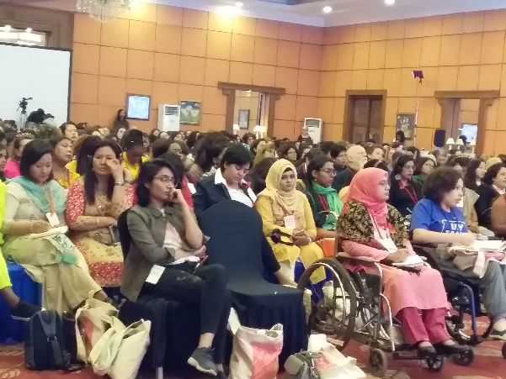A re-conference was being organized by CREA at Saulty Crown Plaza Hotel in Kathmandu, Nepal from 8 to 13 April 2019.

Ashrafun Nahar, Executive Director and Shirmin Akter dolon, General Council Member of WDDF participated in this re-conference. Ashrafun Nahar submitted a brief report of this re-conference:

This re-conference gathered more than 500 women activist from 50 + country and it was a huge gathering. There were Disability sessions where disability issues are being discussed in different panels, e.g. Personal experience of Persons with disabilities, different models of disability, Disability inclusion, disability and sexuality, Nairobi Declaration on Women with Disabilities reproductive health which is very helpful achieving knowledge and gathering diverse concerns from different audience. Besides, panelists were also discussed about convention on Rights of Persons with Disabilities and different policies.

**1st Day 9 April 2019**

In a session titled Disability space where the plan and program schedule of next 3 days is being shared. Disability space was being prepared on 10 April 2019. From 11 to 1 PM, all participants with Disabilities introduced with each other, share their activities and discussed about disability situation of different countries. There were participants from Bangladesh, India, Kyrgyzstan, Mexico, Nepal, New Zealand, Nigeria, Pakistan, Srilanka, Uganda, USA, UK and Uruguay. It is decided that, how the participants will participate and take part as panelist and evening performance in next 3 days.

**2nd Day**

She participated in the 1st plenary session from 10 AM to 12 PM, on 10 April 2019. The plenary session started with the quiz questionnaire on women rights movement and panel discussants were also discussed about feminist movement. Due to not having prepared the venue, the discussion session titled 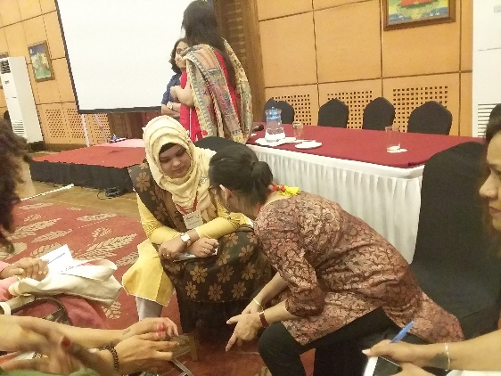Disability space from 12 to 1.30 PM hasn’t been started and they united in a small gathering for next set up. Then after lunch she participated in the session on disability space where the speakers of India, Srilanka and UK are discussed about Convention on Rights of Persons with Disabilities and inclusion. Besides, there were 3 group discussions and one of these group discussions she spoke about disability and country situation.

**3rd Day**

11 April 2019 started with the plenary session. The quiz questionnaire on women rights movement has continued with a number of disability related questions and participants were also response of these questions. The panel discussion on legal framework was held and two speakers of Bangladesh: Barrister Sara Hossain from Bangladesh Legal Aid Services and trust (BLAST) and Shahin Rahman from BRAC University, Department of public health were present with two other speakers.

The next session titled Sport women and their victimizations. Three stories from India are being described in this topic. After lunch, in the session titled Disability space she was panel speaker on disability movement where she illustrated the relation between disability and feminist movement as well as women with disabilities inclusion in this movement. Another session titled Disability space on Nairobi Declaration, three speakers were discussed in this session, Lisa Adams of Australia along with other two speakers of CREA.

**4th Day**

After lunch Ashrafun Nahar and other speakers from Nepal, Uganda, Nigeria. It was a story telling session where she exposed her grown up with disability and story of involvement with disability movement. In Additional session she spoke on how Women with disabilities have been involved with feminist (women rights) movement in Bangladesh.

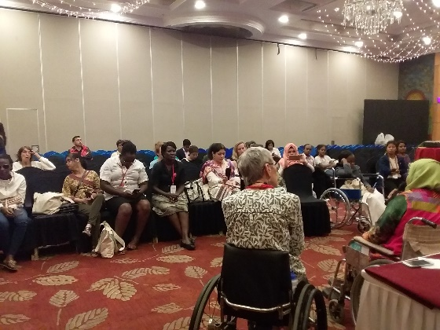Besides, she organized a number of discussion meetings with Sara Hossain, representatives of MamaCash, Tehani of Women’s Fund in Asia (WFA) and Diana Samarsan of Disability Rights Fund (DRF) in different times of those three days.

**Rethink:** In Bangladesh, WDDF is working on both disability and feminist Movement. She started to rethink how Women leaders with Disabilities of Bangladesh could work more effectively on disability movement and feminist movement simultaneously. The number of Women leaders with Disabilities are very limited in Bangladesh but we try to build leadership among girls and women with disabilities in grassroots and national level. In order to ensure inclusion of women and girls with disabilities in feminist movement it is necessary to harmonize these issues of feminism and disability movement which hasn’t yet been possible.

**6. Workshop:**

A Stakeholders consultation workshop on Inclusive Skills development and Employment in the informal sector youth with Disabilities was being organized by BRAC at the Conference room of BRAC Centre on 9 April 2019.

Shirin Akhter, Chairperson and Arifa Khatun, Junior Assistant Coordinator, WDDF participated in this workshop. Shirin Akhter emphasized on limitations of employment of Women with Disabilities informal sector and limitation of required appropriate assistive device for them. Besides, she delivered a presentation about the challenges faced by Women with Disabilities in employment sector.

**7. M**onthly NGO Coordination Meeting:

A monthly NGO Coordination Meeting was being organized by District Commissioner at the Auditorium of DC office, on 16 April 2019. Arifa Khatun, Junior Assistant Coordinator of WDDF participated in this coordination meeting.

**8. Consultation:**

A consultation on Role of Stakeholders in combating sexual Harassment and to prepare a draft legislation was being organized by National Human Rights Commission Bangladesh (NHRCB) at the Conference room of NHRCB on 17 April 2019.

Shirin Akhter, Chairperson and Arifa Khatun, Junior Assistant Coordinator, WDDF participated in this consultation. Shirin Akhter said that, Women with Disabilities are frequently becoming victim of different types of sexual violence simultaneously they’ve to face threats and torture even imprisoned by the offender due to long procedure of justice system and lack of proper observation along with protection strategy for victim. Besides, Shirin Akhter also suggested that, representative of Women with Disabilities should be included in working group of draft legislation and in order to include the issue of Women with Disabilities she also provided inputs in different sections of draft legislation on sexual harassment.

9. **Special Meeting:**

A special meeting on Role of Stakeholders in combating sexual harassment was being organized by Ain o Salish Kendra (ASK) at the Auditorium of ASK on 18 April 2019.

Shirin Akhter, Chairperson and Arifa Khatun, Junior Assistant Coordinator, WDDF participated in this special meeting. Shirin Akhter discussed about extreme sufferings and torture of a victim Girl with Disability and his family due to having claimed justice for sexual harassment. She mentioned that, Women with Disabilities are becoming 3 or 4 times more victim than nondisabled women and existing justice system isn’t supportive and responsive for obtaining justice for Persons/Women with Disabilities. So, the adopted initiatives through this meeting should be disability inclusive and not only Nusrat, who has to sacrificed her life due to claiming justice but also all classes of people including People with Disabilities should have opportunity to enjoy positive result of justice on the basis of equity.

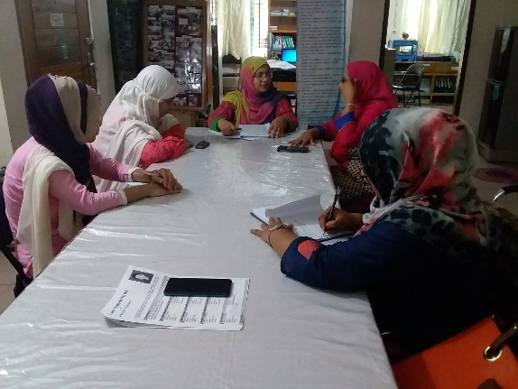**10. Executive Council Meeting:**

An Executive Council meeting was held at WDDF office, on 25 April2019. There were almost ten participants including office staffs. Six agenda have been discussed including miscellaneous in this Executive Council meeting.

11. **Citizens Conclave:**

A Citizens Conclave titled “Four Years of SDGs in Bangladesh” was being organized by Citizen’s platform for SDGs, Bangladesh at Bangabandhu International Conference Centre (BICC) on 27 April 2019.

Shirin Akhter, Chairperson and Arifa Khatun, Junior Assistant Coordinator, WDDF participated in the inaugural session of this Citizens Conclave.

**12. Discussion meeting:**

A discussion meeting about barriers of Child Marriage Restrained ACT 2017 and necessity of review was being organized by Bangladesh Legal Aid Services and Trust (BLAST) at Daily Star Bhaban on 30 April 2019.

Ashrafun Nahar, Executive Director and Samira Haque, Accounts Coordinator, WDDF participated in this discussion meeting. Ashrafun Nahar enquired that, Has Disability issue been included in the survey of Child Marriage and Child Marriage related programs? Specially issues of Girls with Disabilities? Whether this issue is being included what type of approach has been adopted?

**1. Workshop:**

A Workshop on necessity of ratification Marrakesh treaty was being organized by Visually Impaired Peoples Society (VIPS) at VIP Lounge, National Press Club on 2nd May 2019.

Ashrafun Nahar, Executive Director and Samira Haque, Accounts Coordinator, WDDF participated in this workshop. Ashrafun Nahar noted with importance that, it is prerequisite to study different types of books for achieving good result in exam or achieving knowledge but Persons with Visual Impairments or Print Disabilities are deprived from studying all types of books due to haven’t been sign and ratified Marrakesh treaty.

**2. Discussion meeting:**

A Discussion meeting in order to prepare a draft legislation on Combating Sexual Harassment was being organized by National Human Rights Commission Bangladesh (NHRCB) at the Conference room of NHRCB on 6 May  2019.

Shirin Akhter, Chairperson and Arifa Khatun, Junior Assistant Coordinator, WDDF participated in this discussion meeting.

**3. Discussion meeting of CICBD:**

A discussionmeeting of Citizens Initiative on CEDAW Bangladesh (CICBD) in order to adopting decision about shifting secretariat was being organized by Steps towards Development (STD) at the auditorium of STD, on 9 May 2019.

Shirin Akhter, Chairperson and Arifa Khatun, Junior Assistant Coordinator, WDDF participated in this discussion meeting. Shirin Akhter said that, Secretariat might be shifted after having submitted the upcoming CEDAW alternative report but activities have to be done with equal importance. All types of marginalized groups should be included and their proactive participation should be ensured in the meetings and programs considering all types of accessibility requirements. A guideline of shifting and accommodating secretariat should be prepared and time frame of shifting secretariat should be fixed on the basis of report submitting period. A number of organizations might be applied for taking responsibility of secretariat and then members of this platform may select an organization for shifting secretariat.

**4. Discussion meeting on Disability inclusive National Budget 2019-2020:**

A discussion meeting on Disability inclusive National Budget 2019-2020 was being organized by Access Bangladesh Foundation and Action on Disability and Development (ADD)-international Bangladesh at Spectra Convention Centre on 9 May 2019.

Md. Abdul Hai, Junior Assistant Coordinator, WDDF participated in this discussion meeting.

**5. Orientation training about organizational policies:**

It would be noted that, WDDF has been selected as DIPTYA partner of Manusher Jonno Foundation (MJF). Hence, a two days orientation training of DIPTYA partners of Manusher Jonno Foundation (MJF) about organizational policies was being organized by MJF at training centre of MJF from 13 to 14 May 2019.

Shirin Akhter, Chairperson, Ashrafun Nahar, Executive Director and Samira Haque , Accounts Coordinator, WDDF participated in this orientation training. Different organizational policies and proper implementation and utilization of those policies are being discussed in this training elaborately.

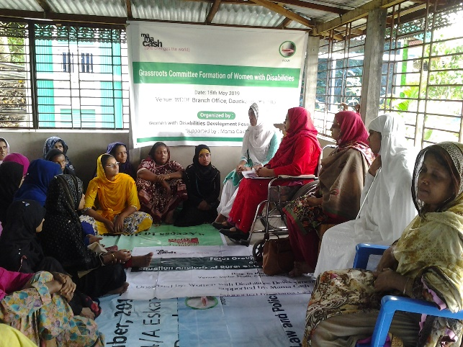**6. Group formation of grassroots Women with Disabilities:**

A discussion meeting in order to form three groups of grassroots Women with Disabilities of four Unions of Daudkandi was being organized with the initiative of Women with Disabilities Development Foundation (WDDF) at branch office of WDDF, Baropara, Daudkandi, Cummilla on 15 May 2019. 38 Women with Disabilities of four unions namely Gouripur, Baropara, Shundalpur and Daudkandi Powrashabha participated in this discussion meeting but the total number of participants of this discussion meeting including Chairperson, Vice-Chairperson, Executive Director, General Council member, office staffs and volunteers were almost 50. Welcome speech is being delivered by Shirin Akhter, Chairperson of WDDF. She discussed about background and activities of WDDF briefly. After that, Ashrafun Nahar, Executive Director, WDDF discussed about purpose of forming these groups and their activities at local level through developing their leadership capacity. She facilitated this discussion meeting and three groups were formed with the cooperation of Masuma Akter, Vice-Chairperson and Fatima Keya, Project Officer of Daudkandi.

Shahanaj Begum, Union Parishad Member of Gouripur was present as special Guest in this discussion meeting. At the end of the meeting, raw iftar ingredients are being distributed among Women with Disabilities.

**7. Public hearing:**

A public hearing on situation of Women with Disabilities in public transport was being organized by BSCAN at RC Mozumdar Hall, Dhaka University on 16 May 2019.

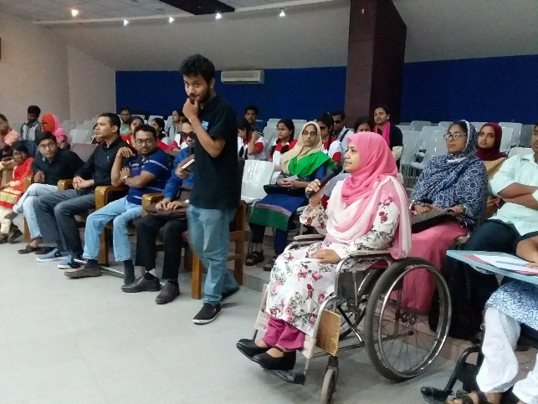Ashrafun Nahar, Executive Director and Arifa Khatun, Junior Assistant Coordinator, WDDF participated in this public hearing. Ashrafun Nahar said that, Though Men with Disabilities are being able to get on public transport with help of people/passengers but Women with Disabilitiesaren’tbeing able to use public transport. So, in this circumstance, she interrogated following questions to the guests/responsible authorities: E.G.

**I)** Has any plan of the authorities of Bangladesh Road and Transport Corporation (BRTC) and Bangladesh Road and Transport Authority (BRTA) to create accessibility of Persons including Women with Disabilities in public transport?

**II)** Will accessibility facilities for Persons with Disabilities be ensured in Metro rail according to the manual of BRTC and BRTA?

**III)** 47 years have already been past after independence of Bangladesh, How many days we’ve to wait more for accessibility of Persons with Disabilities in public transport? How many days more we’ve to raise voice?

**8. Monthly NGO Coordination Meeting:**

A monthly NGO Coordination Meeting was being organized by District Commissioner at the Auditorium of DC office, on 20 May 2019.

Md. Abdul Hai, Junior Assistant Coordinator of WDDF participated in this coordination meeting.

**9. Training on financial policy and management:**

A three days training of DIPTYA partners of Man usher Jonno Foundation (MJF) about financial policy and management was being organized by MJF at training centre of MJF from 21 to 23 May 2019.

Ashrafun Nahar, Executive Director and Samira Haque , Accounts Coordinator, WDDF participated in this training.

**10. Coordination meeting on Disability Inclusive Disaster Risk Management (DIDRM):**

A coordination meeting on Disability Inclusive Disaster Risk Management (DIDRM) between Centre for Disability in Development (CDD) and Disabled Peoples Organizations (DPOs) was being organized by CDD at the meeting room of Disabled Welfare Society (DWS) on 25 May 2019.

Md. Abdul Hai,Junior Assistant Coordinator of WDDF participated in this coordination meeting.

**11. Discussion meeting of CIDV:**

A discussion meeting of Citizens initiative on Domestic Violence (CIDV) was being organized by Bangladesh Legal Aid Services and Trust (BLAST) at the meeting room of BLAST on 28 May 2019.

Arifa Khatun, Junior Assistant Coordinator of WDDF participated in this discussion meeting.

Agenda of this discussion meeting were as follows:

I) Preparing action plan for new secretariat,

II) Advisery committee reforms,

III) Coalition list update and

IV) AOB.

**12. Discussion meeting of Citizens Initiative on CEDAW Bangladesh (CICBD)’s secretariat shifting guideline preparatory committee:**

A discussion meeting of Citizens Initiative on CEDAW Bangladesh (CICBD)’s secretariat shifting guideline preparatory committee was being organized by steps Towards Development at the meeting room of STD on 29 May 2019.

Shirin Akhter, Chairperson and Arifa Khatun, Junior Assistant Coordinator, WDDF participated in this discussion meeting.Shirin Akhter suggested that:

1. A clause should be added for application of organizations and secretariat selection.
2. All types of marginalized group of women should be included considering their types andrequirements.

**III)** Time frame should be fixed considering prior and subsequent activities of CEDAW alternative report submission. IV) Minimum membership fee should be fixed.

**V)** A criteria for enhancing members’ participation should be added.

**13. Roundtable discussion:**

**A roundtable discussion titled ‘What kind of NHRC Do We want’ was being organized by Ain o salish Kendra (ASK) at CIRDAP Auditorium on 30 May 2019.**

Shirin Akhter, Chairperson and Arifa Khatun, Junior Assistant Coordinator, WDDF participated in this discussion meeting. Shirin Akhter suggested that, National Human Rights Commission (NHRC) should be independent and impartial. NHRC should have power of taking strong and proper initiative in order to preserve human rights of all types of marginalized groups and to obtain justice. As NHRC is responsible to protect human rights of all classes of population; So, Chairman and all members including officers of NHRC should have proactive role and responsibility to create an anti-discriminatory environment for full enjoyment of human rights for all classes of staffs through reducing internal discrimination of NHRC office.

**1. Monthly NGO Coordination Meeting:**

A monthly NGO Coordination Meeting was being organized by District Commissioner at the Auditorium of DC office, on 16 June 2019.

Md. Abdul Hai, Junior Assistant Coordinator of WDDF participated in this coordination meeting.

**2. Press conference:**

A press Conference titled **“Post budget reaction. National Budget 2019-20: Situation of Persons with Disabilities”**, focusing the allocated budget for Persons with Disabilities under social safety net in national budget of fiscal year 2019-20, was being organized with the initiative of eight Disabled Peoples Organizations (DPOs), e.g. Access Bangladesh Foundation, Disabled Welfare Society (DWS), Disabled Child Foundation (DCF), National Counsel for the Disabled Women (NCDW), Sign Language for the Deaf and Sign Language Users (SDSL), Turning Point Foundation, Visually Impaired Peoples Society (VIPS), Women with Disabilities Development Foundation (WDDF) in join collaboration at 11.00 AM, on Monday, 17 June 2019, at Conference Lounge, National Press Club in order to discuss about the socio-economic circumstances of Persons With Disabilities and how their advancement is being interrupted due to not having their proper inclusion in national budget. Secretarial support for organizing this press conference has been provided by Access Bangladesh Foundation. The representatives of DPOs, Non-Government Organizations (NGOs) and International Non-Government Organizations (INGOs) participated in this Press Conference.

The main purpose of organizing the press conference is to urge to the Government for formulating disability inclusive national budget on the basis of discussion and suggestion of Persons with Disabilities and DPOs through building accessible and discrimination free socio-economic environment. Simultaneously, to notify Government and the relevant authorities involved with the process of budget formulation that, though national and international legislations and policies have clearly been mentioned about the socio-economic management system of Persons with Disabilities but nevertheless, fundamental rights of them are extremely being violated due to improper budget management and multifaceted challenges in different aspects including inaccessibility. So, it is indivisible to formulate and implement disability inclusive national budget for Persons with Disabilities otherwise achievement and actualization of “Convention on Rights of Persons with Disabilities”, “Persons with Disabilities Rights and Protection Act 2013” and “Sustainable Development Goals (SDGs)” will extremely be interrupted.

These DPOs having united & working as collective force with the Government, policy makers, representatives of civil society and media for the inclusion of People with Disabilities in national budget in order to reducing their challenges and discrimination in different aspects. This press conference was being moderated and the keynote paper was being presented by Albert Mollah, Executive Director, Access Bangladesh Foundation. In this paper he mentioned about socio-economic perspective of Persons with Disabilities of Bangladesh, proportional analysis between the number of Persons with Disabilities and the amount of allocated budget for them, negative impact of allocating budget for Persons with Disabilities under social safety net and rationality of formulating disability inclusive national budget. Persons with Disabilities are depriving from enjoyment of their equal citizen rights including rights of education, health, employment and livelihood. The large number of population with disability in Bangladesh is one of the most vulnerable and disadvantaged segment of the society. Most of them are living under poverty line and roads, footpaths, Underpass, over bridge, public transport, public buildings including education, health, employment and recreational institutions are inaccessible for them. Besides, due to being gender and for having severe disability Persons specially Women with severe Disabilities are often deprived from enjoyment of basic opportunities and lost their interests to life leading. There are a number of examples of Persons with Disabilities who have committed suicide suffering from negligence, poverty , injustice and unemployment problems. Besides, Persons with Disabilities have experience of building and involving with movement in different times and situations for their inclusion in development process. They’re trying their best to notify these issues again and again but nevertheless, due to the negligence of the relevant authorities, lack of proper data collection, lack of proper conception about overall situation of Persons with Disabilities and without considering the demands and requirements of Persons with Disabilities along with disability related legislations and policies disability inclusive national budget hasn’t yet been formulated. Persons with Disabilities don’t want to leave behind through excluding national budget, development plans and programs including eighth five year plan. They want to live together, contribute in building golden Bangladesh and prosperous nation together. So, it is noted that, Persons with Disabilities are always subject of discrimination including human rights violation and without having been enjoyed basic human rights, all types of Persons with Disabilities haven’t been included in the mainstream of development and in this consequence, national development will extremely be interrupted.

Five recommendations are being mentioned in keynote paper of this press conference:

1. To ensure appropriate Statistics of Persons with Disabilities for their full inclusion in development plan.
2. Scholarship should be ensured for hundred% Students with Disabilities.
3. Infrastructural and informational accessibility should be ensured in all areas.
4. Budget should be allocated to create employment opportunity.
5. Ministry based budget should be allocated in order to ensuring inclusive development of Persons with Disabilities.

Welcome Speech of this press conference is delivered by Ashrafun Nahar, Executive Director, Women with Disabilities Development Foundation (WDDF). Closing speech is delivered by Osman Khaled, President, Sign Language for the Deaf and Sign Language Users (SDSL),.

The representatives of DPOs expressed their high optimism that, the flight of steps of establishing the rights and dignity of 24 million of disabled people would be easier and they will be able to play a contributive role as human resource not rather being treated as a burden of society in the development of society and nation and in the consequence of achieving their needs and demands through the proper implementation and actualization of “Convention on Rights of Persons With Disabilities”, “Persons with Disabilities Rights and Protection Act 2013” and “Sustainable Development Goals (SDGs)”. So, the representatives of Women with Disabilities lead organizations call vigorously for the rapid implementation of the convention to actualize the development process of the country. So, they are optimistic that, 24 million Persons With Disabilities will enjoy the equal opportunity similar to all citizen’s and it will be easy to eliminate all forms of barriers to fulfill the demands of Persons With Disabilities and will ensure there full participation in the development activities of the state. Besides them, Executive Council Members and representatives of DPOs also delivered their speech in this press conference. All the speakers in the press conference expressed their optimism that, successful implementation and actualization of national and international instruments including **“Convention on Rights of Persons With Disabilities”** will eradicate all kinds of discrimination between Persons With Disabilities & non-disabled people & will be able to build a happy & anti discriminatory nation.

The press conference was conducted with the leadership of the representatives of DPOs and NGOs including Persons with Disabilities. The Press Conference, which was being organized by 8 organizations, is a very time required and effective initiative. A large number of reporters and photo journalists of Electronic and Print Media were present in this Press Conference. The keynote paper was being distributed among the participants on behalf of these Organizations and a press release was being published at the end of the Press Conference.

**3. Discussion meeting with the Minister, Ministry of Railways:**

A discussion meeting was held between the representatives of WDDF and the Minister, Ministry of Railways in his office on 18 June 2019.

The representatives of Executive Council including the officials of WDDF attended in the above mentioned meeting.

Md. Nurul Islam Sujon, Minister, Ministry of Railways expressed his heartiest thanks to the representatives of WDDF.

Afterwards, Ashrafun Nahar, Executive Director of WDDF, on behalf of the representatives of WDDF, submitted a paper including the accomplishment, objectives along with a few proposals and Shirin Akhter, Chairperson of WDDF, submitted a proposal for installing talking system in all types of trains to the Minister and call upon to express the solidarity on behalf of Ministry of Railways to these issues.

The Minister was very cordial and cooperative to us. Expressing full support and solidarity to our proposals he said that, considering accessibility of Persons with Disabilities, a wide door has been set up and 6 seats are being preserved at Banalata Intercity train and we’ll adopt more initiative to make disability friendly Railways by rotation. He also said that, present Government is very compassionate to Persons with Disabilities and very much committed to fulfill their demands.

Above all, it is said that, in the present perspective, the adopted initiative by WDDF, of organizing this discussion meeting between the representatives of WDDF and the Ministry of Railways in order to include Women with Disabilities in the mainstream of development by ensuring their equal rights along with dignity is really very time required and effective. At the end of the discussion meeting, the representatives after having been attended in the above mentioned discussion meeting expressed their satisfactory feelings and positive remarks.

**4. Executive Council Meeting:**

An Executive Council meeting was held at WDDF office, on 19 June2019. There were almost ten participants including office staffs. Six agenda have been discussed including miscellaneous in this Executive Council meeting.

**5. Workshop:**

**A** workshop on Beijing+25 national review was being organized by UN Woman Bangladesh at Royal Park Residence and Hotel, at 9.00 AM, 20 June 2019.

Shirin Akhter, Chairperson and Samira Haque, Accounts Coordinator, WDDF participated in this workshop. Shirin Akhter notified that, Women with Disabilities have to face multifaceted challenges; e.g. issues of Women with Disabilities haven’t been addressed in “Persons with Disabilities Rights and Protection Act 2013” and implementation process of this legislation is extremely deliberate. Disability identification survey hasn’t being conducted properly so all development programs including national budget have been designed without considering disaggregated data of Women with Disabilities. Education scholarship of Persons with Disabilities should be increased. Any clause addressing Women with Disabilities and their violence hasn’t been included in “Women and Children Repression prevention Act 2000”.

So, Shirin Akhter on behalf of Women with Disabilities urged to mention these challenges in Beijing+25 national review and a written note about challenges of Women with Disabilities has been submitted to the reporter.

**6. Consultation:**

A consultation about submitted alternative report on Convention on Rights of Persons with Disabilities (CRPD) and a draft alternative report on Convention Against Torture (CAT) is going to be submitted on behalf of Persons with Disabilities was being organized by National Grassroot Disabled Organization (NGDO) at conference room of Manusher Jonno Foundation (MJF), at 2.00 PM, on 20 June 2019.

Shirin Akhter, Chairperson and Samira Haque, Accounts Coordinator, WDDF participated in this consultation. Shirin Akhter suggested that, members of CRPD platform should organize discussion meeting in order to prepare List of Issues (LOIs) of CRPD which would be very helpful for preparing more effective LOIs. Besides, before participating next CRPD Conference of State Parties, a number of discussion meetings should be organized by the members of CRPD platform in order to preparing statement and questions for the Committee on Rights of Persons with Disabilities otherwise important issues won’t be included in concluding observation.

About draft alternative report on CAT, Shirin Akhter said that, it is a very time required decision to submit alternative report on CAT on behalf of Persons with Disabilities but time is too short to provide inputs in CAT alternative report. She also suggested that, torture and sufferings of victim Girls/Women with Disabilities due to filing litigation of violence/rape happening towards them should be included in CAT alternative report.

**7. Grassroots Women with Disabilities committee meeting:**

**A)** First discussion meeting with the Grassroots Women with Disabilities Committee of ‘Gouripur’ and ‘Baropara’ Daudkandi, Cumilla was being organized by WDDF, at WDDF branch office, Kanora, Gouripur Union on 24 June 2019. This meeting is presided over Shirin Akhter, Chairperson, WDDF with the cooperation of Masuma Akter, Vice Chairperson, Fatima Keya, Project Officer and Arifa Khatun, Junior Assistant Coordinator of WDDF.

The discussed issues of this meeting were:

**I)** Introductory session.

**II)** Discussion about name and necessity of consisting of this committee.

**III)** Discussion about purpose of consisting of this committee.

**IV)** Discussion about Chairperson, Vice-Chairperson and Member Secretary Selection (Note: Chairperson Aulia Khatun, Vice-Chairperson Jabeda Akter, Member Secretary Sima Akter of Gouripur and Baropara union) of grassroots Women with Disabilities committee.

**V)** Discussion about definition and types of disability.

**VI)** Discussion about WDDF.

**VII)** Miscellaneous.

**B)** Second discussion meeting with the Grassroots Women with Disabilities Committee of ‘Sundalpur and ‘Daudkandi Powrasabha’ Daudkandi, Cumilla was being organized by WDDF, at WDDF branch office, Kanora, Gouripur Union on 25 June 2019. This meeting is presided over Shirin Akhter, Chairperson, WDDF with the cooperation of Masuma Akter, Vice Chairperson, Fatima Keya, Project Officer and Arifa Khatun, Junior Assistant Coordinator of WDDF.

The discussed issues of this meeting were:

**I)** Introductory session.

**II)** Discussion about name and necessity of consisting of this committee.

**III)** Discussion about purpose of consisting of this committee.

**IV)** Discussion about Chairperson, Vice-Chairperson and Member Secretary selection (Note: Chairperson and Vice-Chairperson Mina Rani Sarkar, Member secretary Shahanaj Kulsum Ani of sundalpur union, Chairperson and Member Secretary Halima Akter, Vice-Chairperson Sharmin Akter of Daudkandi Powrasabha union) of grassroots Women with Disabilities committee.

**V)** Discussion about definition and types of disability.

**VI)** Discussion about WDDF.

**VII)** Miscellaneous.

**8. Consultation:**

A **c**onsultation on “SDGs: climate change and Human rights” was being organized by National Human Rights Commission Bangladesh (NHRCB) at Panpacific Sonargaon Hotel on 27 June 2019.

Md. Abdul Hai**,** Junior Assistant Coordinator of WDDF participated in this consultation. Abdul Hai focused on adverse impact of climate changing towards Women with Disabilities. He said that, adopted activities in order to protecting affected people from adverse impact of climate changing should be disability inclusive; especially considering situation and requirement of Women with Disabilities otherwise endeavor of achieving SDGs will be interrupted.

**9. Workshop:**

A workshop on Identification of gaps and challenges to ensure disability inclusive services were being organized by a2i at Conference room of (Level 13), Bangladesh Computer Council Bhaban on 29 June 2019.

Rounak Jahan Usha, Treasurer, Ashrafun Nahar, Executive Director and Md. Abdul Hai,Junior Assistant Coordinator of WDDF participated in this workshop. These three participants are being divided in to different groups and submitted written recommendation for ensuring disability inclusive services through identification of gaps and challenges properly.